Grade Kindergarten
Bananas in a Box Game

Description: | Students will:  Draw a banana.  Create a script for it with forward by and turn by tiles.  Make copies of the banana.  Rotate the copies.  Make a pattern from the rotated shapes.  Use a playfield as a collection place for bananas that have been caught while the scripts are running.  Use a detailed watcher to show how many bananas have been caught.
Project View | 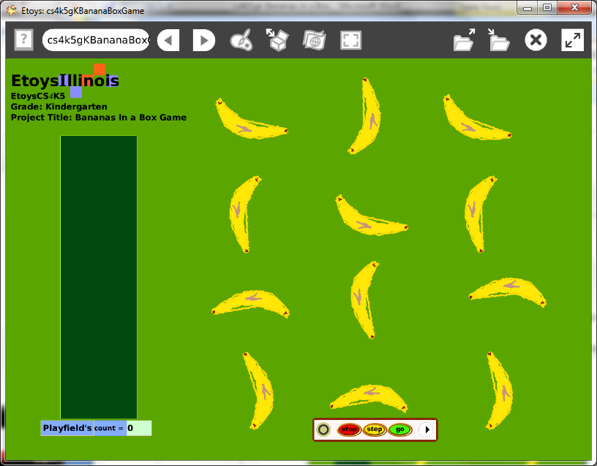
Subject: | Math
Etoys Quick Guides | Click the question mark in Etoys to open the set of interactive tutorials for basic tools and techniques.
Vocabulary: | Counting, shapes, patterns, up, down, left, right, above, below, beside, between, how many, fast, slow, forward, turn
Lesson 1:  Paint Tools: Brushes  Halo Handles: Viewer  Script Tiles: Forward and Turn  Navigator Bar: Keep Find Projects | Ask students to draw a banana. (Any fruit or vegetable or other simple to draw object.)  Make a script for it with forward by and turn by in one Scriptor. Give students time to experiment with the numbers so that the banana moves around on their screen fast enough to be interesting but slow enough to be caught with the cursor while the script is running.  Use the halo for the world’s magenta handle to change the color of the world.  Get a playfield from Supplies and use its magenta halo handle to change the color of the playfield. The playfield will be used to collect the fruit like a game net and score.  Keep the project. Students type their name and the fruit for example: kateBanana
Lesson 2:  Halo Handles: Size, Color, Copy  Navigator Bar: All Scripts  Halo Handles: Rotate Handle | Make copies of the banana. Let students make as many as they want. Give them time to play, to count, and to see other’s projects.  Use an All Scripts button from Supplies to start and stop all the scripts at one time.  Ask students to use the Halo handle to rotate bananas to point in different directions and then make patterns from that variety of results. Assure children that they can add or remove bananas to complete the pattern they have imagined.  The All Scripts Go button will disrupt the still pattern, but the motion of bananas will be predictable if students observe what is happening. Students can build the old pattern again or try a different one in a different location.  Students should Keep the project when they have experimented enough to know a pattern they like.
Lesson 3: | Open a Viewer for the playfield, click on basic to open a menu and click on Collections.  Click on the white menu to the left of the playfield count tile and then click on detailed watcher. Put this tile under the playfield and it will tell students how many bananas are in the box.  Give students time to play with their game and to try other students’ games and to see other students try their game. Discuss what they find out from trying other games and from watching other people play theirs.  Give them time to make changes to their project.  Students will enjoy making this project again and again with different objects. Perhaps the letters of their name, a favorite toy, or something the class has been studying would be a good starting place for a new version of this project.
Standards: | Common Core Standards  Mathematics: K.CC1,5; K.OA.1,2,3  Language Arts: L.d.e  Bloom’s Taxonomy/Cognitive Domain:  Knowledge: knows, selects  Comprehension: gives examples, explains  Application: produces, uses  Analysis: analyzes, compares  NETS  1. a, b, c, d  3. a  4. a, b, c
Resources: | Etoys Help Quick Guides: always available in Etoys. Open Etoys and click the question mark to open a set of interactive tutorials of basic tools and techniques.  www.EtoysIllinois.org projects, lesson plans, software download  www.MSTE.Illinois.org math, science, and technology resources  www.corestandards.org Common Core Standards  www.Squeakland.org software and Etoys projects  www.nctm.org Standards and Focal Points for each grade level
kh January 2011

